<https://apigee.com/edge>

[niranjanpanigrahi2009@gmail.com/Pintu@12345](mailto:niranjanpanigrahi2009@gmail.com/Pintu@12345)

API gateway acts as layer

Through API gateway layer all the APIs are exposed

Security is important which implemented in API gateway layer

Apigee helps securing the APIs with oauth, tokens and thread production policies.

Provides API proxies

Scaling API

Analytics

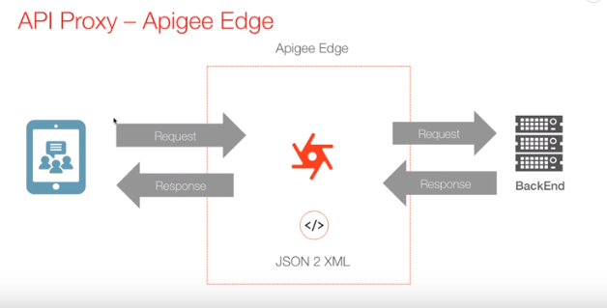

It can be useful for transforming xml to json and vice versa.

For above purpose API proxy are used

Sample API proxy:

<http://mocktarget.apigee.net/json>

Proxied API

<http://niranjanpanigrahi2009-eval-test.apigee.net/mockproxy>

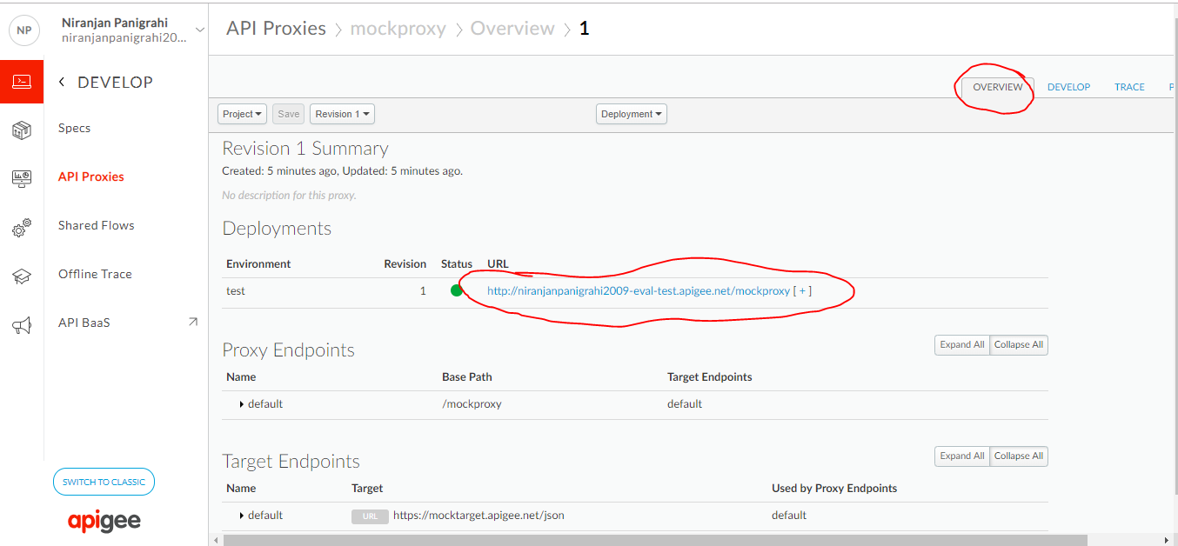

We can trace the api calls by starting trace session.

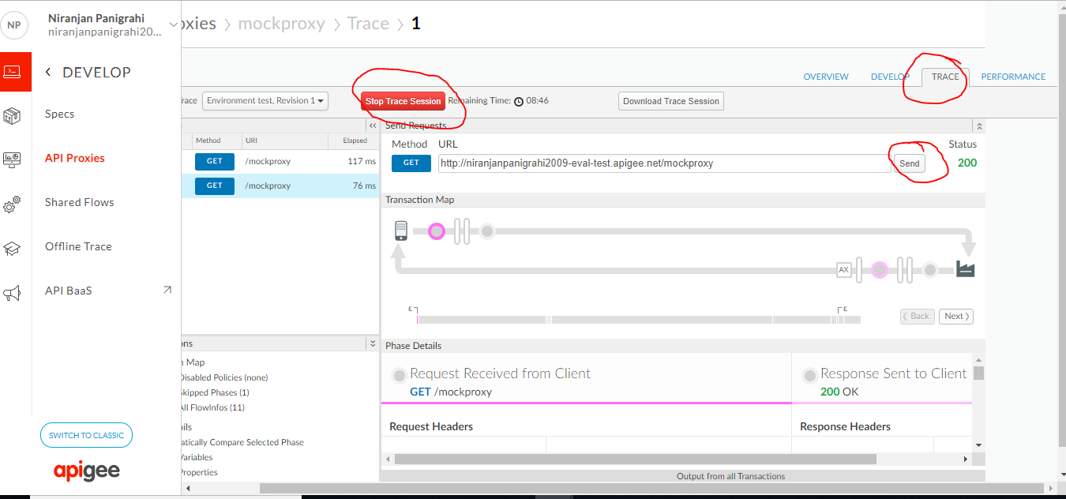

Api transformation is done in the develop tab both request and response

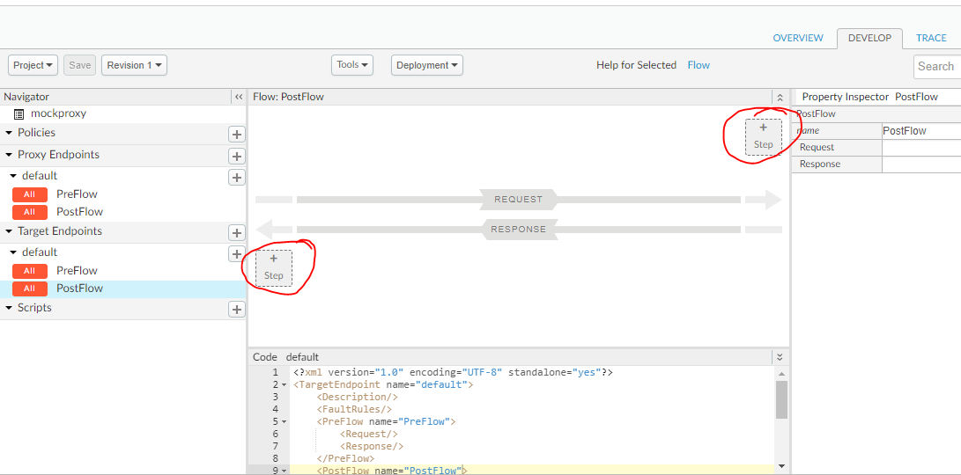

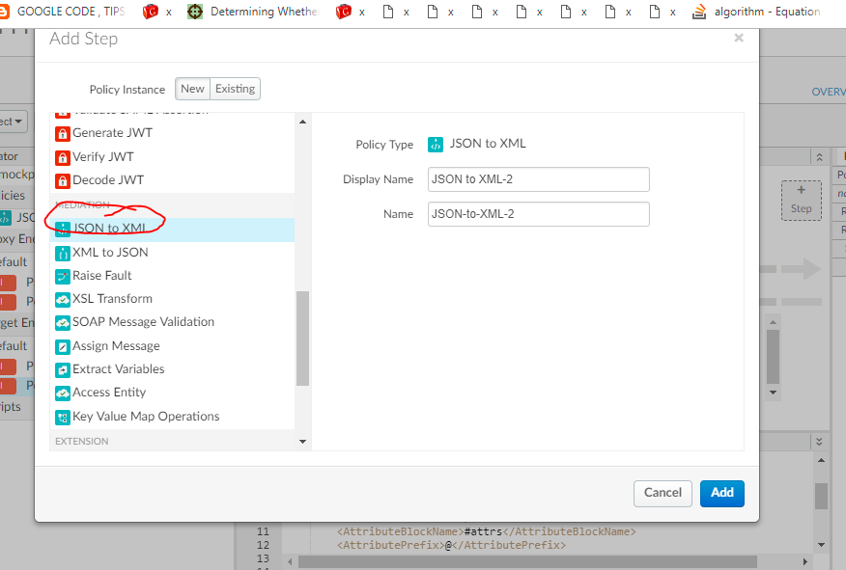

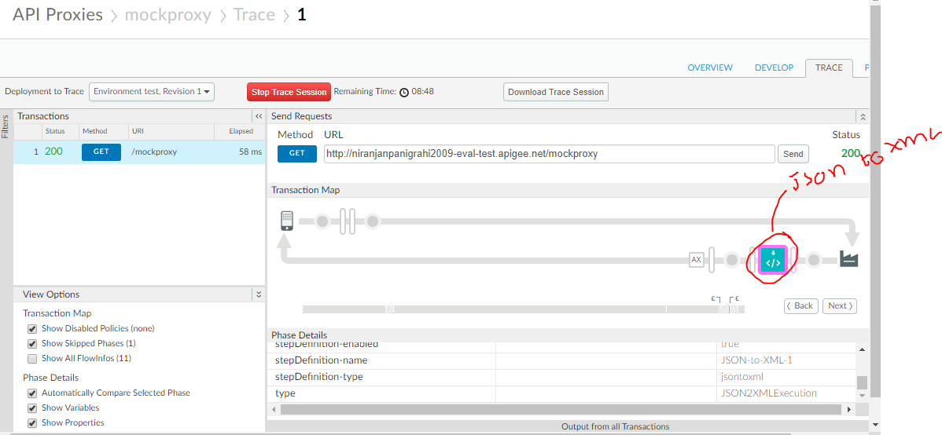

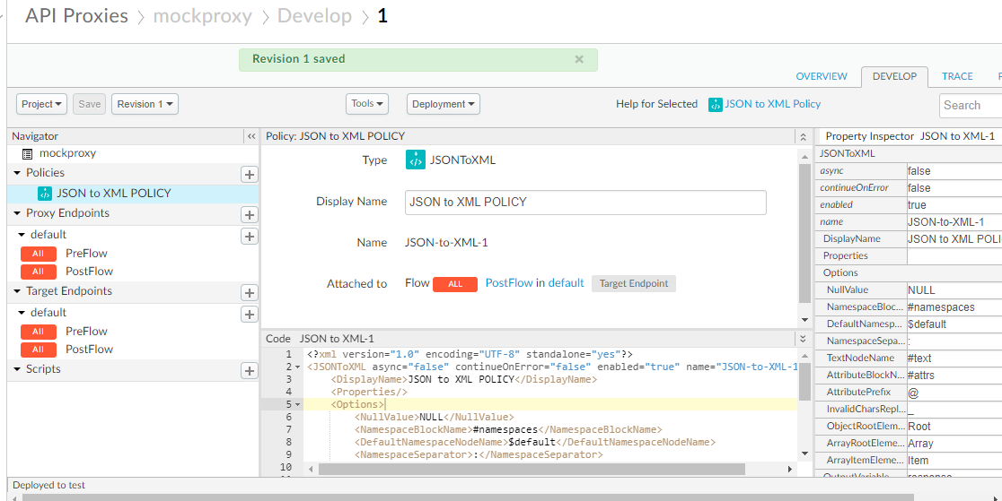

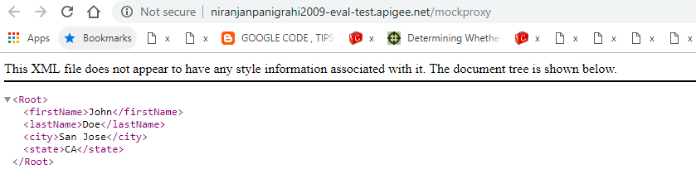

Apigee will be helpful while completely transforming the request, extracting the request parameters from the request, creating a new request call with new request parameter name, with which name the server is expecting us to call. Similarly while sending the response back we can modify the response or we can add some headers.

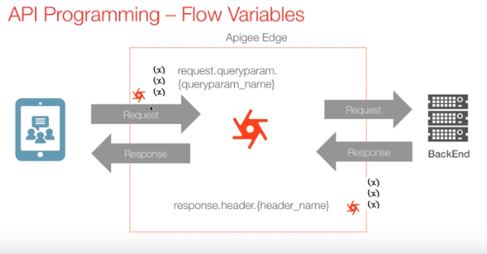

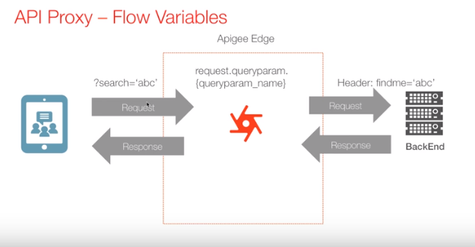

Original link:

<http://httpbin.org/get>

Proxied URL:

<http://niranjanpanigrahi2009-eval-test.apigee.net/flowvariabledemo>

We can get the sample

<https://community.apigee.com/articles/36145/apigee-4mv4d-programming-of-apis-series-request-re.html>

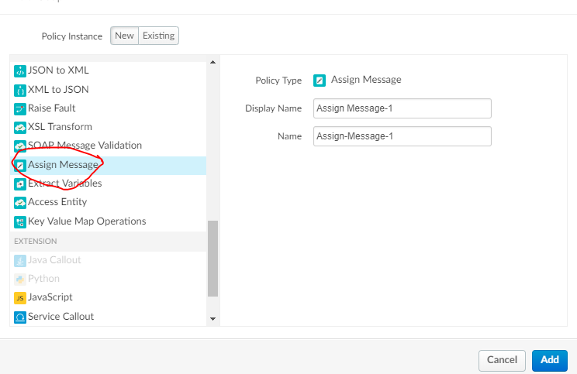

<?xml version="1.0" encoding="UTF-8" standalone="yes"?>

<AssignMessage name="CopyQueryParamToHeader">

<DisplayName>populateHeaderFromQueryParam</DisplayName>

<AssignTo createNew="false" type="request"/>

<Set>

<Headers>

<Header name="findme">{request.queryparam.search}</Header>

</Headers>

</Set>

<Remove>

<QueryParams>

<QueryParam name="search"/>

</QueryParams>

</Remove>

</AssignMessage>

The above assign message is extracting the query parameter **search** and passing as header parameter **FindMe** and finally removing the query parameter.

<http://niranjanpanigrahi2009-eval-test.apigee.net/flowvariabledemo?search=123>

op without applying AssignMessage

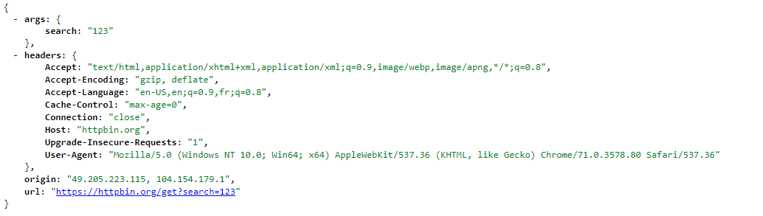

op after applying AssignMessage

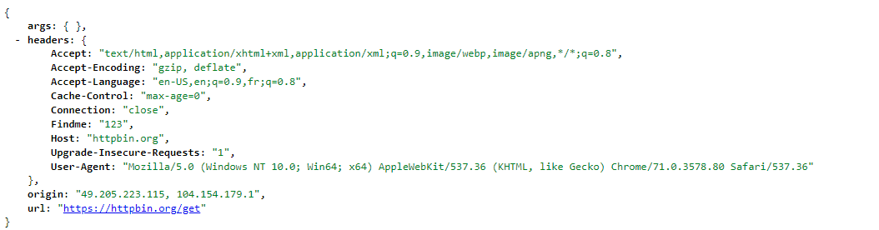

**Proxy Endpoint & Target Endpoint**

<http://mocktarget.apigee.net/>

<http://niranjanpanigrahi2009-eval-test.apigee.net/proxyendpointtargetendpoint>

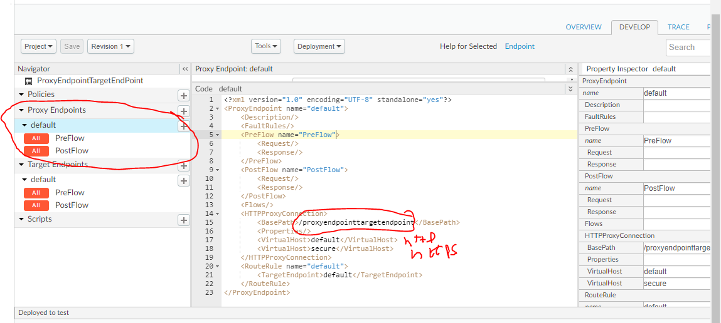

We can change the basepath

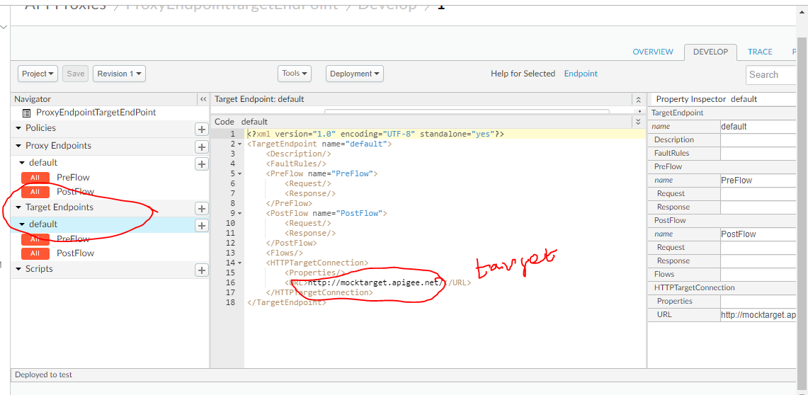

# API Proxy Flows

# 

# 

Any request comes from the client first hits proxy endpoint.

The first layer that by default gets executed is **PreFlow**

Then it hits the **Conditional Flow** which gets executed conditionally

Then by default **PostFlow** gets executed.